MAZE GAME DESCRIPTION

I have used as many elements of the Unity game engine as possible to create an interactive game environment with a FPS player. I focused on creating a visually aesthetic environment that draws the player in. It combines elements of probuilder, animation, rendering cameras , and direct as well as other sources of lighting.

BEGINNING OF GAME DESIGN

TERRAIN (25%)

I have included environment textures, trees and foreign materials, water, fog, wind, and billboard textures and materials to the outdoor section of my game.

I have also added a first-person controller with which the player can navigate the scene.

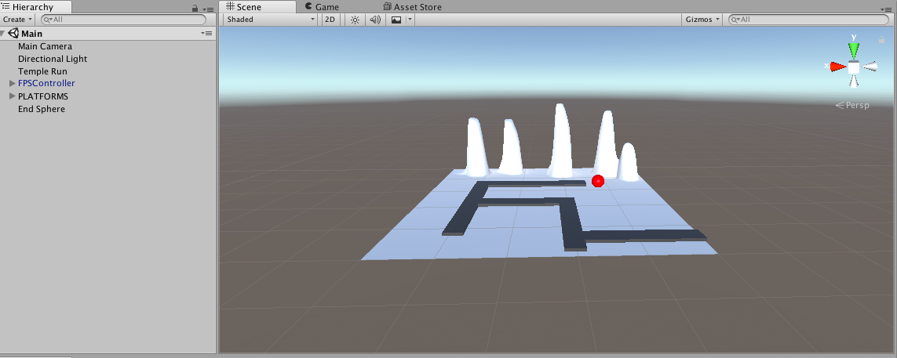

I had a very basic terrain with a few platforms and a sphere made using Unity primitives. I had also added some texture and height to terrain as shown above. I made my very first material too with the shade red.

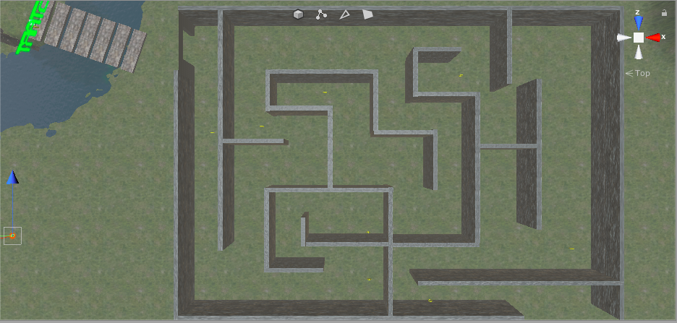

I started adding some texture and details to my terrain like grass, trees and hills and crevices as well as creating a material for my maze walls. I then started creating the basic layout of my maze structure using unity shapes and also created a coin prefab with an animation. The goal was to get this coin to be picked up by the player as a trigger. I also added normal maps to the game

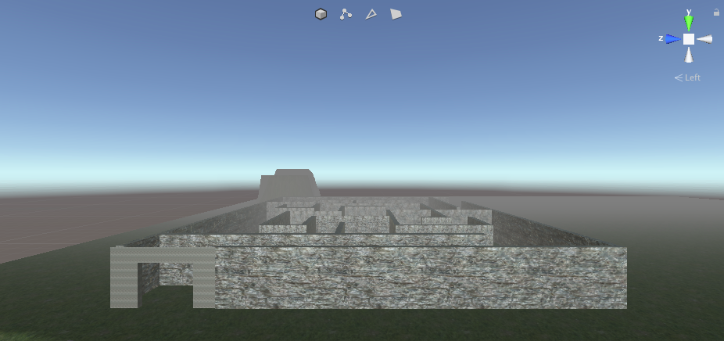

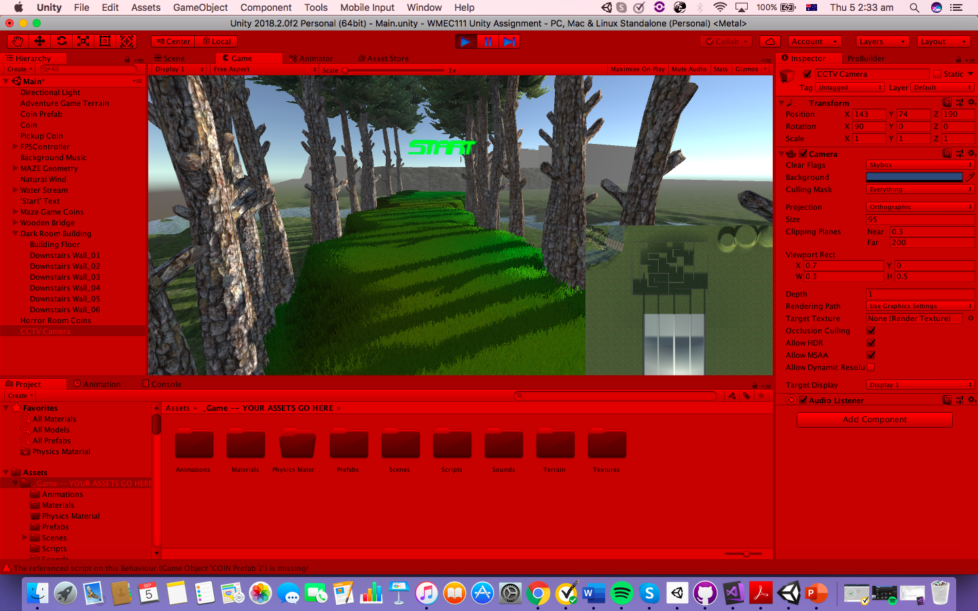

I then added a FPS controller to my scene and edited the directional lighting in my terrain. I also added a stream and a bridge using the script provided by unity. This was followed by adding a minimap camera and some post-processing effects to the game enhance the game-play feel.

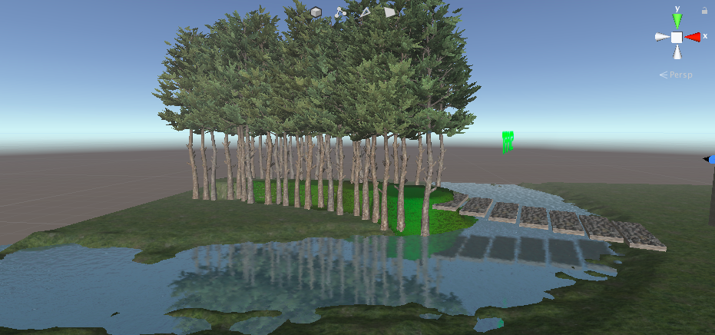

I also attempted to create hinge joint bridge.

INDOOR SECTION (25%)

For the indoor section of the game I have used created materials, textures, lighting, pro-builder shapes to create a simple maze like game that requires players to collect coins before they reach the end of the game. I have also used textures for bump mapping and normal maps.

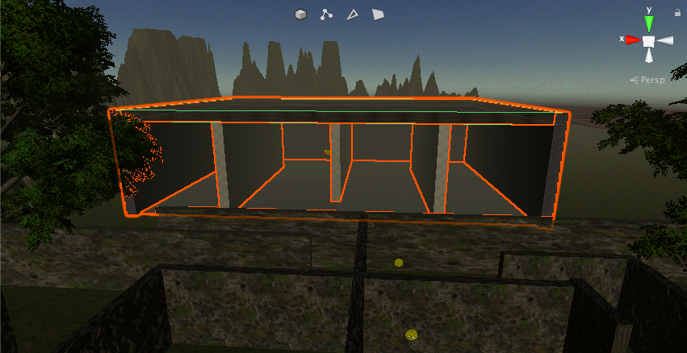

I also added some point lights to the inside of my building to keep it lit up during the night cycle of the game. I also added some appropriate textures to the inside of my building using available textures.

MODIFICATIONS OT GAME DESIGN DOCUMENT

I made a few major changes to the original game idea because I realised it is difficult to create a running game within Unity and that a maze game allowed the player to explore their surroundings and find it more adventurous and engaging.